Team World Vision Hood to Coast Relay 2023: South Sudan

OVERVIEW
Project Name | Enhancing Water Security and Resilience: Hydrometeorological Approaches to Strengthening Water Resources Management in Upper Nile State, South Sudan
Project Location(s) | Upper Nile State: Baliet and Malakal Counties
Project Budget (Year 2) | $169,835 ($668,750 budget in FY22)

PROJECT GOALS AND STATUS
South Sudan is recently faced its worst floods in nearly 60 years, with the Upper Nile among the worst-affected states. In addition to providing food and temporary shelters, World Vision is working with partners to enhance water security and effective water resources management in two counties (Baliet and Malakal) in the Upper Nile state that experience recurrent flooding and dry cycles.
During floods, communities are displaced and are put at risk of contracting water-borne diseases. In dry periods, water scarcity pushes communities that live far from the rivers to move in search of grazing lands. This can exacerbate incidences of interethnic conflicts as different communities compete for resources. This project aims to address these challenges through four main outcomes:
- Outcome 1: Enhance water resources decision-making by establishing a hydrometeorological database in partnership with the Ministry of Water and Ministry of Infrastructure. Key steps include installing three meteorological stations across three sub-catchments and three river gauging stations along the Sobat and Nile Rivers and working with the ministries to compile this data.
  - Year 1 Progress:
    - MOU signed with the state government who will lead in providing technical guidance to the project
    - Identified sites for the installation of the meteorological and river gauging stations; civil work completed for these sites in preparation of equipment arrival
    - Procurement of technical equipment to install meteorological and river gauging stations
  - Year 2 Plans:
    - Installation of meteorological and river gauging stations
    - Data collection and monitoring
- Outcome 2: Construct three 30,000 cubic-meter reservoirs, each equipped with a small solar-powered water treatment system, to provide flood protection and harvest water during rainy seasons for productive use during dry periods.
  - Year 1 Progress:
    - Collaborated with state government, local authorities, and community leaders to identify sites for reservoirs
    - Completed site preparation for construction
    - Procurement of water treatment system equipment
  - Year 2 Plans
    - Construct reservoir and water treatment system
- Outcome 3: Increase rainwater catchment and reduce runoff volume during floods by establishing fruit-tree nurseries and woodlots as buffer zones. Fruit-tree seedlings will be distributed to 5000 farmers and 100 farmers will receive training on woodlots.
  - Year 1 Progress:
    - Distributed of 1063 mango and avocado tree seedlings
    - Trained 98 farmers on establishing woodlots as buffer zones near bodies of water
  - Year 2 Plans:
    - Establish nursery beds for additional fruit-tree nurseries
    - Distribute seeds to trained farmers to establish woodlots
- Outcome 4: Build local watershed management capacity by forming and training five Water Catchment Management Associations across five sub-catchments, five Water User Management Committees, and developing one water catchment integrated management framework and plan.
  - Year 1 Progress:
    - Formed and trained five water catchment management associations (10 members each)
    - Formed and trained five water user management committees (10 members each)
    - Drafted watershed management framework
  - Year 2 Plans:
    - Ongoing engagement with water catchment management associations and water user management committees
    - Completion of watershed management framework

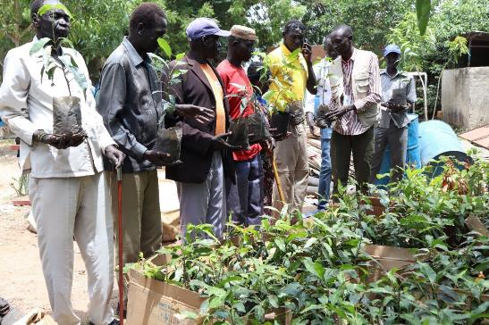

Fruit tree seedling distribution at Malakal River Port station. 1093 mango and avocado tree seedlings were distributed.

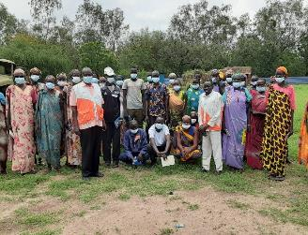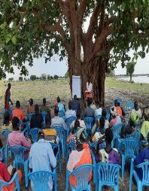

Farmers trained on how to establish woodlots as buffer zones near bodies of water in Malakal (left) and Baliet Towns (right).

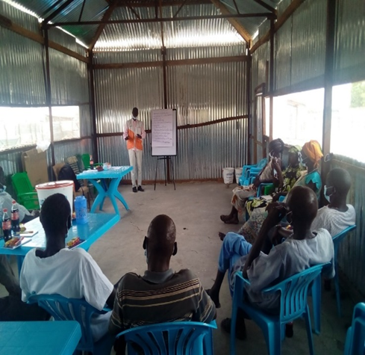
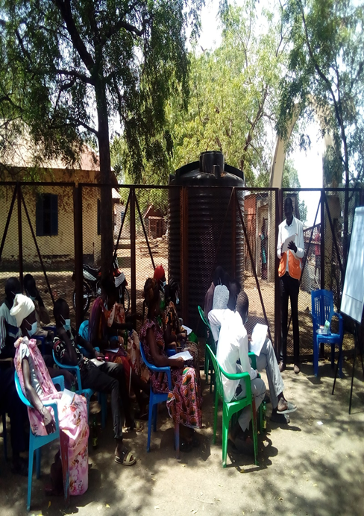

Water security and resilience conducted trainings of water resource management committees and water resource user associations both received trainings on water security and resilience. After the training, Nyanjima Mayau Miyen from Malakal Town shared
“We will be moving out from here to convey out hygiene messages and publicize them to our families and communities. World Vision is a real organization that we all know [is] supporting people with water sanitation and hygiene and therefore, I will give thanks to God [that] World Vision continues to support us here.”

OVERVIEW
Project Name | South Sudan WASH: World Vision US Base Funding
Project Location(s) | Central Equatoria, Northern Bahr Ghazal, Upper Nile, Warrap, and Western Equatoria States
Total Project Budget | TBD

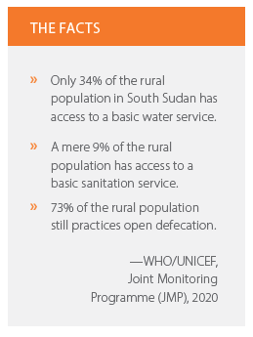
PROJECT BACKGROUND AND GOALS
The South Sudan WASH Program aligns with the World Vision South Sudan FY21-FY25 National Strategy, which aims to improve the well-being of children through the integration of WASH into other sector projects in 18 counties across five states (Central Equatoria, Northern Bahr Ghazal, Upper Nile, Warrap, and Western Equatoria). This strategy is realized through a WASH technical team of 38 (including five women) and an annual WASH budget of more than $5 million from all funding sources.
Annual targets (2023) of the South Sudan WASH Program include the following:
- 142,058 people gaining access to safer, more accessible drinking water and improved sanitation and hygiene facilities.
- 31 schools gaining access to clean drinking water on site
- 37 HCFs gaining access to water on premises, providing water essential for cleaning and handwashing

