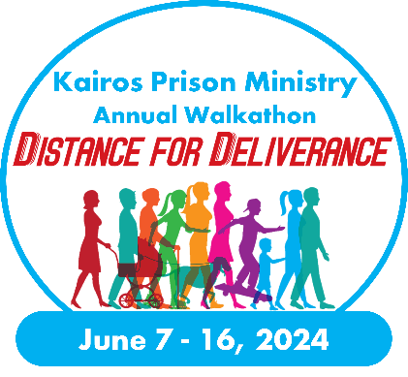
Dear [First Name],

On behalf of Kairos [Advisory Council Name] I extend my more sincere thanks to you in choosing to support this ministry so close to my heart. Thank you for your donation of $ [##] on M/D/YYYY.

Due to your generosity, I was able to raise $ [#,###] and our walk was able to raise a total of $ [##,###] all in support of those impacted by incarceration, both inside and outside prison walls. Through your involvement with the Distance For Deliverance Walkathon, we are able to bring the love and forgiveness of Jesus Christ to those we minister to by both holding Kairos Weekends and our ongoing Continuing Ministry efforts.

I am so grateful for your support as we all work together to ensure those in prison or juvenile detention centers know they are loved and cared for, and that the families on the outside have the support and love they deserve. This combination of ministry efforts ensures an optimal and nurturing environment for when an innate is released, so they are likely not to reoffend while becoming a positive influence on our community.

Thank you and God bless,

[Name]

