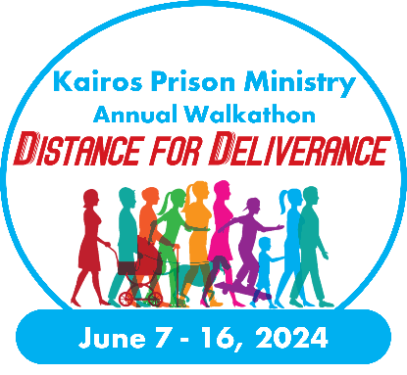
Offline Pledge Form
This printable form is available for participants to gain pledges offline. Please fill out all the blank spaces and make sure that the participant you are sponsoring is listed correctly to be sure that the money is applied to their fundraising goal. See [Insert Team Fundraising page or Facebook Fundraiser URL] for more information on this event.

Support the 2024 Distance for Deliverance Walkathon

My Pledge is Sponsoring (participant or team name): ________________________________________________

Name: ______________________________________________________________________________

Address: ____________________________________________________________________________

City: _________________________________ State: ________ Zip: _____________________

Phone: ________________________________ Email Address: ________________________________

Payment Information:

Enclosed is my check in the sum of $___________________
Please make check(s) payable to: [Kairos of State or Advisory Council]

Please charge my donation to:
Check one: Visa Mastercard AMEX Discover
Check Check number: _______________________

Credit Card Number: __________________________________________________________

Name (As it appears on credit card): _____________________________________________________

Expiration Date: _____/_____ CVV/Security Code: ____________

Please Note: The address above must match the address that is associated with your credit card.

Please mail this form and your check(s) to:
[Kairos State or Advisory Council Name]
Attention: [Your Name or Fundraising Coordinator]
[Street Address or PO Box]
[City, State, Zip Code]

Kairos Prison Ministry is a 501(c)(3) organization designated by the Internal Revenue Code.
All donations are tax-deductible.

