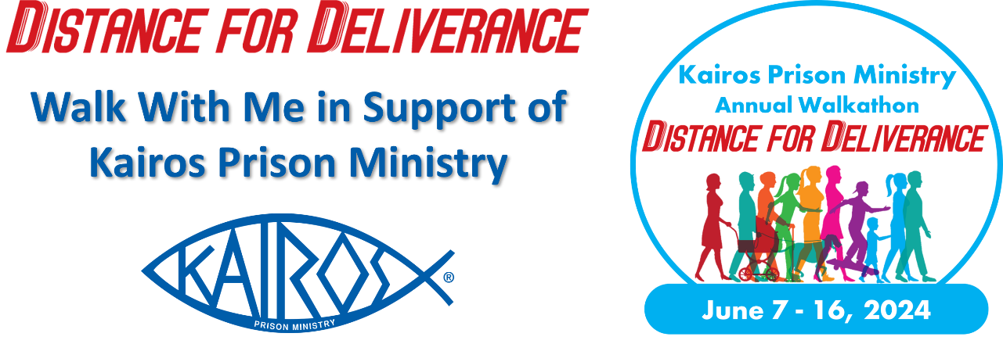
Dear [Name],
Kairos [Advisory Council Name] is proud to be participating in the Distance for Deliverance Walkathon to raise funds for our upcoming Weekends, Continuing Ministry, and general operations. As you may know Kairos Prison Ministry serves those impacted by incarceration, whether they are men, women, or youth, and whether they are locked up or have a loved one who is incarcerated. This ministry is especially close to my heart, and I am excited to be walking for Kairos during the Distance for Deliverance Walkathon taking place on June [Date], 2024.
I am asking for your support in a donation of $ [XX] to help me reach my goal of $ [XXX]. By supporting me, whether it is $ [XX] or any amount, I assure you that every dollar raised during this campaign will be used to bring the love and forgiveness of Jesus Christ to those impacted by incarceration. This ministry really does transform lives in the most literal sense. Whether you donate $5 or $5,000, every little bit helps, and it will all be used to make an immediate positive impact on our community.
Kairos programs are offered free of charge to all we serve with the cost of about [$X,000] per Weekend covered by donors. Will you support me in donating $[XX] for Kairos [Advisory Council]?
You can support me this June by visiting [Insert URL of your fundraising page or Facebook Fundraiser] and joining my team as a participant or as a donor.
Thank you for your support and God bless you and your loved ones,
[Your Name]

