Changing Hearts
Transforming Lives
Impacting the World

[Recipient’s Name]
[AddressLine1]
[AddressLine2]
[AddressLine3]

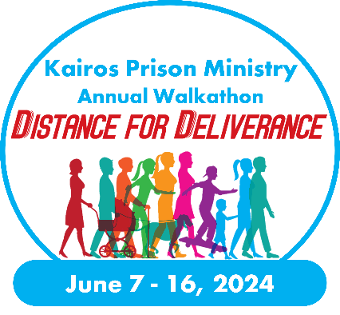
Dear [Name],

I would like to invite you to support me as I participate in the Distance for Deliverance Walkathon supporting Kairos [Advisory Council or State Name] taking place June [Date], 2024. Kairos Prison Ministry serves those impacted by incarceration by bringing them the love and forgiveness of Jesus Christ. This ministry goes into prisons and youth facilities to minister directly to those who are incarcerated, as well as serving the women who are “serving time” alongside their loved on in prison.
I will be walking [XX] miles and am asking for your donation of $ [XX]. By supporting me, whether it is by donating $ [XX] or any amount, every dollar raised during this campaign will be used by Kairos [Advisory Council or State Name] to literally transform lives.
Can I count on your support to ensure that we can hold our Weekends and conducting our Continuing Ministry? We offer all our programs completely free, with the costs covered by generous supporters such as yourself. Will you support my efforts to fund [Kairos Program or Location] with a donation of $ [XX] during the Distance For Deliverance Walkathon?
You can support me this June by visiting [Insert fundraising URL] and joining my team as a participant or as a donor. [Alternatively, you can fill out the attached pledge form return it to me.] Kairos Prison Ministry is a 501(c)(3) nonprofit organization, and all donations are tax deductible under tax ID# 59-1970458.
Sincerely,
[Your Name]
[Street Address]
[City, State, Zip Code]

(Kairos overview below is optional)
Kairos is a lay-led, interdenominational Christian ministry in which volunteers bring Jesus Christ’s love and forgiveness to prisoners and their families through three programs:
- Kairos Inside, for incarcerated men and women
- Kairos Outside, for female relatives and friends of the incarcerated
- Kairos Torch, for incarcerated youth
What starts as a Weekend program, a short course in Christianity, is then maintained through Continuing Ministry by the Guests and Participants. Studies have shown that our programs reduce recidivism, prison violence, unite families, and transform lives.

