General Questions - 1
Customizable Templates - 3
Social Media – 7
Facebook Fundraisers – 9
Logos – 11
Donation Sheet – 12
Contents
Walkathon
Fundraising Toolkit
To Raise Awareness and Funds for Kairos
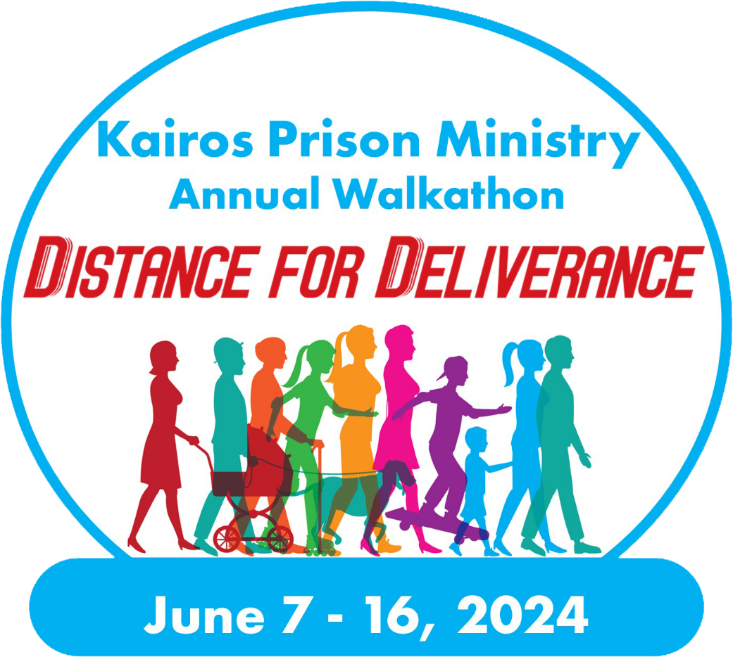

What is the Distance for Deliverance Walkathon?
General Questions About the Walkathon
This annual event is a great way to raise awareness and raise funds for Kairos Prison Ministry. In 2023, the Distance For Deliverance Walkathon will be held between June 7 – 16. Walks will be held around the country for Advisory Councils and the Kairos Community.

I want to participate, what should I do?
Visit www.distancefordeliverance.org or use the QR code for the full list of the available walks. If one is not available nearby, help set one up for your community. Email marketing@kpmi.org for more information about setting up and holding a walk.
Each participant is encouraged to sign up and register for their walk. After registering, you will be able to customize your fundraising page to showcase why Kairos is important in your life, what your community is doing and the impact of Kairos.
You may also create a Facebook Fundraiser for Distance for Deliverance and link it to your fundraising page so you can see all your raised funds in one place.

How do we raise awareness and raise funds?
- Set a fundraising goal – Having a personal fundraising goal helps to generate more donations as donors are more willing to give to help you meet your goal. When making your fundraising asks, ensure to incorporate your fundraising goal.
- Ask for support - Decide who you will be asking for support. Encourage everyone in your Advisory Council and Kairos Community to participate, ask your friends and family to support you, as well as those in your church, co-workers, your neighbors, other organizations that support your local community, local businesses, and anyone else you can think of who would want Jesus in the lives of those impacted by incarceration! Ask those who choose to support you to reach out to their networks as well. While you are asking for support from the various members of the local community, you can also recruit new volunteers.
- Post to social media – Posting to social media is a quick and simple way to notify your friends and family that you are participating in the walk and to make your fundraising ask. Once you register for a walk, you will be prompted to create a Facebook Fundraiser which will be linked to your personal fundraising page, so you can see all your donations in one place. The fundraising toolkit includes sample social media posts that you can fill in with your story and fundraising links.
- Send Emails (ready-made templates are available in your Walkathon dashboard) - After registering for a walk, your fundraising page has a “messages” tab where you can send out messages by importing a list of email address and customizing the pre-made templates to tell your story and make your fundraising ask. You may also use the general Distance for Deliverance email template and customize it as needed to email from your personal email.
- Involve your church – share your participation with your church and other churches in your community. Include a blurb in the church bulletin or newsletter, hand out information after service, involve the church’s social or walking group, or use any other way to get the word out to the church.
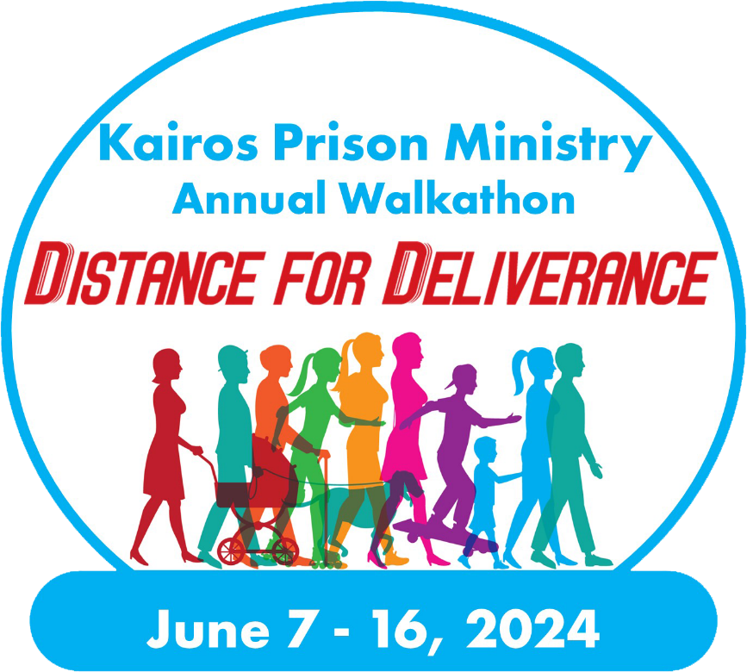
This guidebook includes numerous ways for you to fundraise, with samples of emails, social media posts and graphics, direct mail letters, many of which can be customized to allow you to fill in the details of your Advisory Council’s information, but also to tell your story. Remember, when someone supports you during this event, they are likely to be moved mostly by your personal experience with Kairos and why this ministry is so important in your life. Use your story to really let your experience with Kairos shine through in all your fundraising.

Provided are several customizable templates for a variety of uses in getting the word out about the Walkathon and raising funds. You are encouraged to add your story and your own details to these templates. Donors are likely to support you because of your connection to Kairos, so make it clear how Kairos has impacted your life and why volunteering for Kairos is such an important part of your life.
Customizable Templates

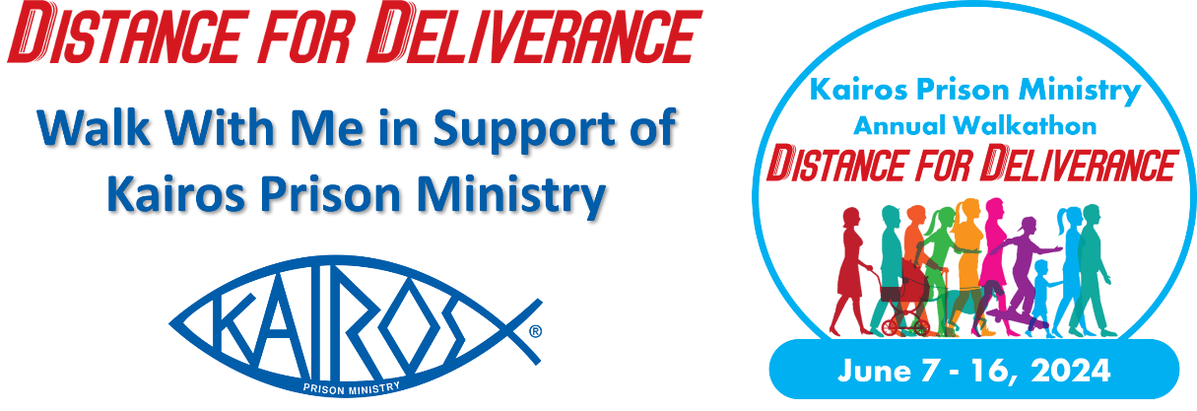
Sample Email Template
Dear [Name],
I am proud to support Kairos [Advisory Council Name] by participating in the Distance for Deliverance Walkathon to raise funds for our upcoming Weekends, Continuing Ministry, and general operations. As you may know Kairos Prison Ministry serves those impacted by incarceration, whether they are men, women, or youth, and whether they are locked up or have a loved one who is incarcerated. This ministry is especially close to my heart, and I am excited to be walking for Kairos during the Distance for Deliverance Walkathon taking place on June [Date], 2024.
I am asking for your support in a donation of $ [XX] to help me reach my goal of $ [XXX]. By supporting me, whether it is $ [XX] or any amount, I assure you that every dollar raised during this campaign will be used to bring the love and forgiveness of Jesus Christ to those impacted by incarceration. This ministry really does transform lives in the most literal sense. Whether you donate $5 or $5,000, every little bit helps, and it will all be used to make an immediate positive impact on our community.
Kairos programs are offered free of charge to all we serve with the cost of about [$X,000] per Weekend covered by donors. Will you support me in donating $[XX] for Kairos [Advisory Council]?
You can support me this June by visiting [Insert URL of your fundraising page or Facebook Fundraiser] and joining my team as a participant or supporting me as a donor.
Thank you for your support and God bless you and your loved ones,
[Your Name]

Sample Direct Mail Template
Kairos Prison Ministry International, Inc.
“I was in prison and you visited me.” Matthew 25:36

[Recipient’s Name]
Changing Hearts
Transforming Lives
Impacting the World

[AddressLine1]
[AddressLine2]
[AddressLine3]

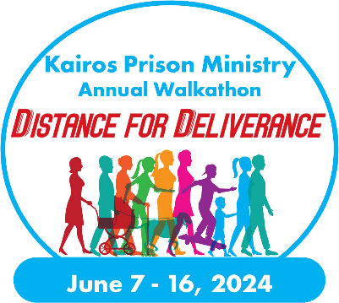
Dear [Name],

I would like to invite you to support me as I participate in the Distance for Deliverance Walkathon supporting Kairos [Advisory Council or State Name] taking place June [Date], 2024. Kairos Prison Ministry serves those impacted by incarceration by bringing them the love and forgiveness of Jesus Christ. This ministry goes into prisons and youth facilities to minister directly to those who are incarcerated, as well as serving the women who are “serving time” alongside their loved on in prison.
I will be walking [XX] miles and am asking for your donation of $ [XX]. By supporting me, whether it is by donating $ [XX] or any amount, every dollar raised during this campaign will be used by Kairos [Advisory Council or State Name] to literally transform lives.
Can I count on your support to ensure that we can hold our Weekends and do our Continuing Ministry? We offer all our programs completely free, with the costs covered by generous supporters such as yourself. Will you support my efforts to fund [Kairos Program or Location] with a donation of $ [XX] during the Distance For Deliverance Walkathon?
You can support me this June by visiting [Insert fundraising URL] and joining my team as a participant or as a donor. [Alternatively, you can fill out the attached pledge form return it to me.] Kairos Prison Ministry is a 501(c)(3) nonprofit organization, and all donations are tax deductible under tax ID# 59-1970458.
Sincerely,
[Your Name]
[Street Address]
[City, State, Zip Code]
(Kairos overview below is optional)
Kairos is a lay-led, interdenominational Christian ministry in which volunteers bring Jesus Christ’s love and forgiveness to prisoners and their families through three programs:
- Kairos Inside, for incarcerated men and women
- Kairos Outside, for female relatives and friends of the incarcerated
- Kairos Torch, for incarcerated youth
What starts as a Weekend program, a short course in Christianity, is then maintained through Continuing Ministry by the Guests and Participants. Studies have shown that our programs reduce recidivism, prison violence, unite families, and transform lives.

[Advisory Council Mailing Address] | Phone: [Advisory Council or Personal Phone #]
[Advisory Council or Kairos State Website URL]

Sample Thank You Letter

While anyone who donates through the DonorDrive online platform will receive an automated email thank you letter that also acts as a receipt, you are encouraged to send your own thank you letters after the event, whether it be sent through email or direct mail.
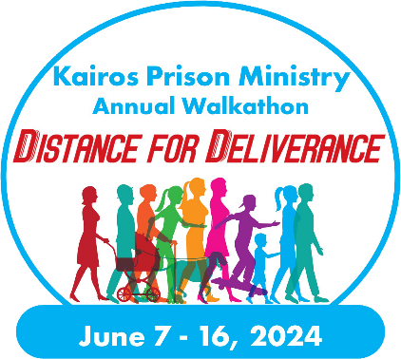
Dear [First Name],

On behalf of Kairos [Advisory Council Name] I extend my more sincere thanks to you in choosing to support this ministry so close to my heart. Thank you for your donation of $ [##] on M/D/YYYY.

Due to your generosity, I was able to raise $ [#,###] and our walk was able to raise a total of $ [##,###] all in support of those impacted by incarceration, both inside and outside prison walls. Through your involvement with the Distance For Deliverance Walkathon, we are able to bring the love and forgiveness of Jesus Christ to those we minister to by both holding Kairos Weekends and our ongoing Continuing Ministry efforts.

I am so grateful for your support as we all work together to ensure those in prison or juvenile detention centers know they are loved and cared for, and that the families on the outside have the support and love they deserve. This combination of ministry efforts ensures an optimal and nurturing environment for when an innate is released, so they are likely not to reoffend while becoming a positive influence on our community.

Thank you and God bless,

[Name]

Fundraising through social media platforms remains one of the most cost-effective ways to raise funds and awareness, plus it’s easy!
Social Media
Facebook, Twitter, Instagram, even Snapchat and TikTok provide each one of us with an easy way to stay connected with our friends and loved ones, but each social media platform is effectively an address book, allowing you to easily share your Distance For Deliverance message to an extended network of potential supporters. This could include those who you may not have connected with recently or those who haven’t heard of Kairos. This is a perfect time to reach out and rekindle an old relationship and share your social media post about Distance for Deliverance, your Facebook Fundraiser, or just send them a direct message. You may even connect with a forgotten friend in the process!

How to Fundraise Using Social Media
Post status updates to all your social media platforms to spread awareness of Distance for Deliverance and Kairos in general. You can also use the platforms to directly ask for donations and share updates on how your fundraising efforts are progressing. Here are some general ideas of what you can post to social media:
- Your personal story of how you came to be a part of Kairos and how Kairos impacted your life
- Photos of you or your team walking
- Updates on how you are progressing towards your fundraising goal
- Direct request for donations
- Links to your personal or team Distance For Deliverance fundraising page
- Thank you posts for those who have already supported you.
- Create a short video about your plans to participate in the Distance For Deliverance Walkathon
Use the hashtag #DistanceForDeliverance in your posts to help amplify our social media footprint!
Tag Kairos Prison Ministry on Twitter @KairosPrisonMin
Tag Kairos Prison Ministry on Facebook at @KairosPrisonMinistry

Social Media Post Ideas
- Sponsor me as I walk the Distance for Deliverance Walkathon for Kairos [Advisory Council or State Name] on June [XX] to raise funds for our programs to assist those impacted by incarceration. Visit [URL] to join my team.
#DistanceForDeliverance
- Kairos Prison Ministry is very near to my heart as it has transformed my life as well as so many others whose lives are impacted by incarceration. I ask for your support as I walk for Kairos [Advisory Council or State Name] on June [XX] as a part of the #DistanceForDeliverance Walkathon to raise funds for our programs.
- Join me as I participate in the Distance for Deliverance Walkathon to support Kairos Prison Ministry. All donations received will go directly to Kairos [Advisory Council or State] to make an immediate impact in serving those whose lives are impacted by incarceration.
#DistanceForDeliverance

- On June [XX] I will be walking to raise awareness of prison ministry and those we serve through Kairos Prison Ministry. I ask for your support in reaching my fundraising goal of $ [X,XXX] with the promise that every dollar is used to enrich the life of someone impacted by incarceration.
- Join me as I participate in the Distance for Deliverance Walkathon to support Kairos Prison Ministry. All donations received will go directly to Kairos [Advisory Council or State] to bring the love and forgiveness of Jesus Christ to those impacted by incarceration.
#DistranceForDeliverance
- Sponsor me as I walk in Kairos Prison Ministry’s Distance for Deliverance Walkathon on June [XX]! I am asking for $ [XX] as I walk [XX] miles to raise funds to bring the love and forgiveness of Jesus to those impacted by incarceration. Visit [URL]!
#DistanceForDeliverance
- Kairos Prison Ministry changed my life, and I am asking for your support in helping to change the lives of others as well. Support me at [URL] as I participate in the Distance for Deliverance Walkathon on June [XX] with funds going to assist those impacted by incarceration.
#DistanceForDeliverance
- I am bringing the light of Jesus into the darkness of prisons by participating in Kairos Prison Ministry’s Distance for Deliverance Walkathon and am asking for your support in donating $[X] as I walk on June [XX], to raise the funds needed to run our Kairos Programs, all of which are completely free to those we serve. Visit [URL] to support this incredible ministry.
#DistanceForDeliverance

Using Facebook Fundraisers to Raise Funds
Anyone can create a Facebook Fundraiser for the Distance For Deliverance Walkathon, which can be easily shared with all of your Facebook friends. You may do this from your personal fundraising dashboard after you register for a walk. This way your Facebook Fundraiser will be linked to your DonorDrive personal fundraising page so can see all your donations in one place. Your personal fundraising page text is automatically copied to your Facebook Fundraiser, which you can then customize if you choose. Just a couple of clicks and it is set up! All funds donated through a Kairos Prison Ministry Facebook Fundraiser will be deposited in the KPMI bank account and then be distributed to your Advisory Council. Please ensure that you include your Advisory Council name in the title of your Facebook Fundraiser!

Official Distance for Deliverance Logo
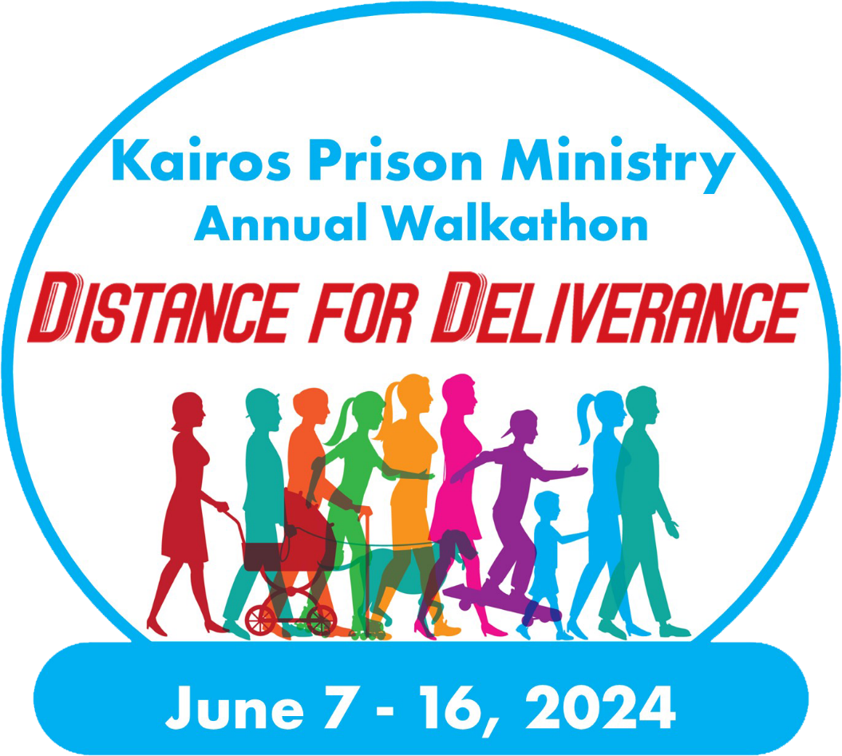

Official Text Logo

Distance for Deliverance Printable Donation Sheet
June [Date]
in support of Kairos [Advisory Council or State Name]
Name: _______________ Fundraising Goal: ____________
I am participating in the 2024 Distance for Deliverance Walkathon in support of Kairos Prison Ministry, an organization that is very close to my heart. We bring the love and forgiveness of Jesus Christ to those impacted by incarceration, both to the men, women, and youth who are incarcerated, but also to the women who have a loved one on the inside and are “serving time” alongside them.
I will be walking [#] miles and would love to have your support! Will you please sponsor me in making a tax-deductible donation to Kairos [Advisory Council]? I am asking for a donation of $ [XX] which would really help me to reach my fundraising goal, or a donation of any amount, would be an incredible blessing.
Name of Donor | Amount | Cash | Check | Online
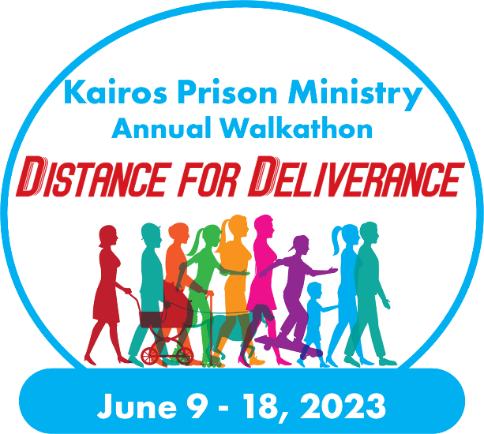
Totals
Please help me reach my goal of raising $ [###] for Kairos [Name of Advisory Council or State]. I can accept cash, checks made out to [Advisory Council Kairos of State], or you can donate at [URL]. Your donation is greatly appreciated and will be accompanied by a tax receipt.
Thank you for your support of this great ministry and for literally transforming the lives of those impacted by incarceration.

Questions
For any further questions you may have about signing up for the 2024 Distance for Deliverance Walkathon, please contact the international office at marketing@kpmi.org or by calling 407-629-4948.

