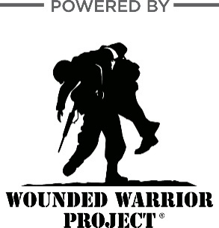
ABC MIDDLE SCHOOL - WALKATHON

On [DATE], I will be participating in the [SCHOOL NAME] [ACTIVITY] benefitting Wounded Warrior Project® (WWP). Our classroom is raising money to help the injured veterans whom WWP serves. I hope you can help by sponsoring me!
Sponsor Name | Phone Number | Pledge per [LAP] | (or) Flat Donation | Total Amount

This pledge form will need to be returned to [TEACHER] prior to the [ACTIVITY]. Once completed, a note will be sent indicating the total [ACTIVITY] [STUDENT NAME] accomplished. You will then be able to collect the pledges via cash or fundraising link and turn them back in to [TEACHER] with your pledge form.

