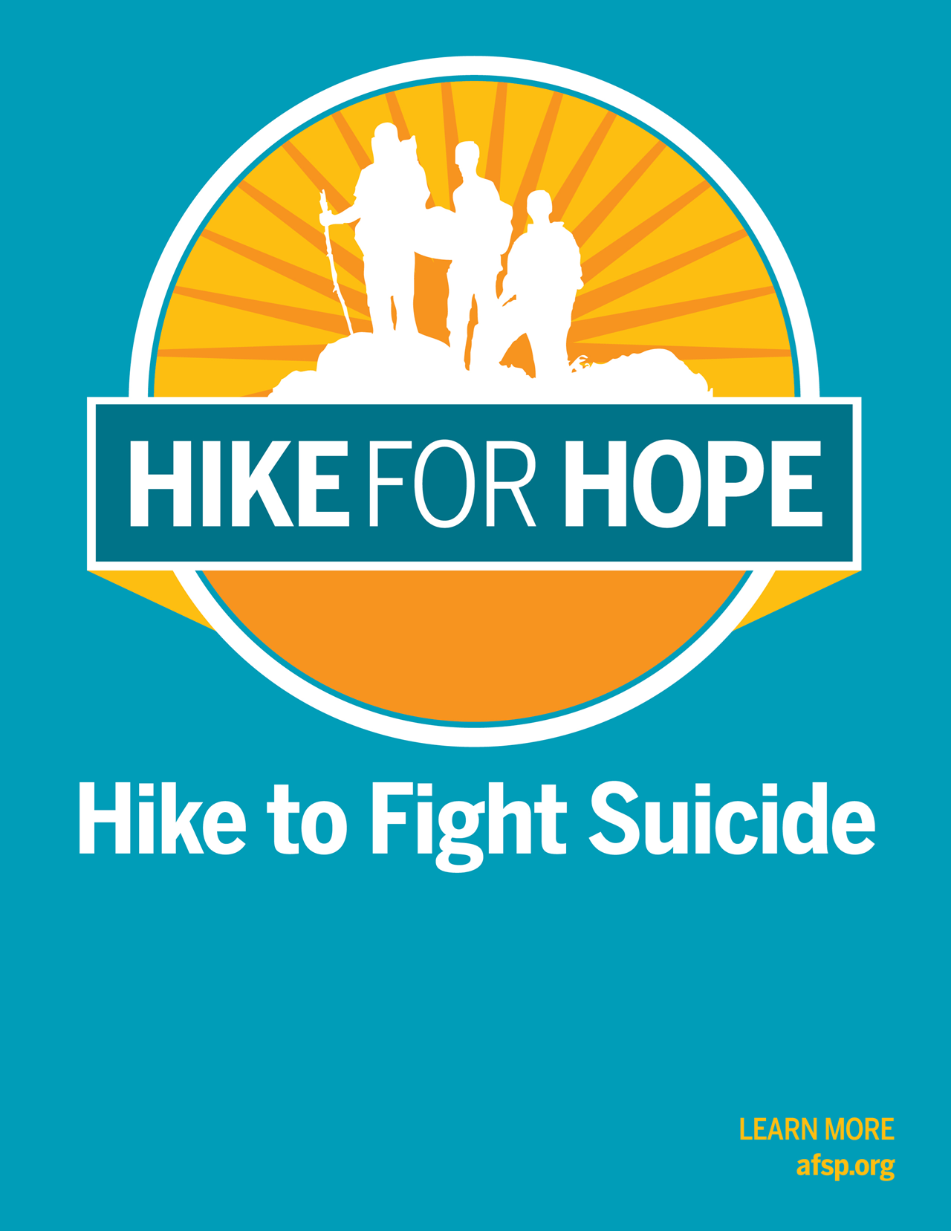
www.afsp.org/galveston

Saturday, March 23, 2024
10am – 1pm
McGuire Dent Rec Center at Menard Park
Galveston, TX

afsp.org/galveston

Saturday, March 26, 2022
10:00 am - Noon
McGuire-Dent Recreation Center at Menard Park
Galveston, TX

2022 <Event NAME>
Sponsorship Opportunities
afsp.org/EventURL

You can be an everyday hero in the fight against suicide.
Partner with us as a Platinum event sponsor for the Third Annual Galveston Hike for Hope, taking place on March 23, 2024, at McGuire-Dent Rec Center at Menard Park.
Why support the Galveston Hike for Hope?
Suicide is a leading cause of death – and it is preventable. With your support, we’ll be one step closer to achieving our bold goal of reducing the suicide rate 20% by 2025.
Build your brand’s goodwill by supporting a cause everyone can get behind.
Our participants are passionate supporters of the cause, with 78% of online registrants indicating a personal investment in suicide prevention. And goodwill goes a long way: 91% of global consumers are likely to switch brands to one associated with a good cause, given comparable price and quality.
Not only are consumers making purchase decisions with purpose top of mind, they are also buying and advocating for purposeful brands. 72% of consumers would recommend a brand that supports a good cause over one that doesn’t.

Sponsor the Galveston Hike for Hope and show our community that you’re a voice for suicide prevention.

The American Foundation for Suicide Prevention leads the fight against suicide.
Funds raised from The American Foundation for Suicide Prevention events allow us to fund research, create educational programs, advocate for public policy, and support survivors of suicide loss.
I look forward to discussing our 2024 sponsorship opportunities and benefits with you in more detail.
For more information, please contact:
Terri Sudduth
Hike for Hope Chair
afspGalveston@yahoo.com
Enclosures

Galveston Hike for Hope
2024 Sponsorship Levels

Platinum Level Sponsor | Donate $3,000
Benefits Include:
Gold Level Sponsorship Benefits listed below.
10 complimentary 2024 Galveston Hike for Hope t-shirts.
Your company listed as sponsor in 4 mailings of 2024 Galveston Hike for Hope eNewsletter (1,500+ Subscribers!)
Table for your company’s team at the event.

Gold Level Sponsor | Donate $2,000
Benefits Include:
Silver Level Sponsorship Benefits listed below.
Your company recognized in announcements at event and our FB page.
8 complimentary 2024 Galveston Hike for Hope T-shirts.
Sign at event listing your company as an event sponsor.

Silver Level Sponsor | Donate $1,000
Benefits Include:
Bronze Level Sponsorship Benefits listed below.
Your company recognized in announcements at event.
4 complimentary 2024 Galveston Hike for Hope T-shirts.
Your company listed as sponsor in 2 mailings of 2024 Galveston Hike for Hope eNewsletter (1,500+ Subscribers!)
Your company’s name, contact information, and logo listed in event program.
Your company name listed on an individual sponsor sign.
Your company’s logo on the back of participant t-shirts and on our walk website that includes a hyperlink to your company’s site.

Bronze Level Sponsor | Donate $500
Benefits Include:
Blue Level Sponsorship Benefits listed below.
Your company’s name on the back of participant t-shirts and on our walk website.
2 complimentary 2024 Galveston Hike for Hope t-shirts.
Your company’s name and contact information listed in event program.
Your logo on the 2024 Galveston Hike for Hope website that links to your company’s website.

Blue Level Sponsor | Donate $250
Benefits Include:
The opportunity to support the nation’s leading non-profit organization dedicated to understanding and preventing suicide through research, education and advocacy, and to reaching out to people with mental disorders and those impacted by suicide.
A tax-deductible donation & donation receipt
1 complimentary 2024 Galveston Hike for Hope t-shirt.
Your company’s name listed in the event program.

Galveston Hike for Hope
2024 Sponsorship Agreement

Please Print
Name/Company:

Mailing Address:
City: State: Zip:

Contact Name:

Phone: Email:
Company Website Address:
Please select one of two sponsorship options:
Cash Sponsorship:  Platinum Level Sponsor | Donate $3,000  Gold Level Sponsor | Donate $2,000  Silver Level Sponsor | Donate $1,000  Bronze Level Sponsor | Donate $500  Blue Level Sponsor | Donate $250 | OR | In-Kind Sponsorship:  Vendor (Product):  OR  Vendor (Service):  In-kind Vendor Sponsorships are a minimum of $100  Non-Profit vendor sponsorships are a minimum of $50

Additional Options:
Call me, I am interested in forming a team for the event
Unable to sponsor, but would like to be a vendor at the event.
Unable to sponsor, but please accept this donation$
Referred by (if someone referred you to us, please let us know):
We authorize The American Foundation for Suicide Prevention to include our corporate name and logo on all event materials consistent with our sponsorship selection and publication dates.

Authorized Signature: Date:
Donation Via:
Enclosed Check Invoice Required to Process Payment
(Please note, “Hike for Hope Galveston” on all checks)
Credit Card: AMEX Mastercard Visa Discover
CARD NO.
EXP. DATE: CODE: BILLING ZIP:
Card Holder Name (if different than Contact Person Name):
Completed & Signed Agreement with Logo Due by Friday, January 26, 2024
Logo Specifications: T-shirt: Vector file (EPS, PS, PDF) format to ensure logo integrity. Website: Stacked logos appear best (max width is 80px) and we accept vector files and/or image files (.jpeg, .png).
Please scan and email or mail this agreement, logo, & Website link to:
Email: AFSPGalveston@yahoo.com or CHazim@afsp.org | Mail: AFSP, ATTN: DEVELOPMENT, 199 Water St, 11th FL, New York, NY 10038
Thank You for Your Generous Support of the American Foundation for Suicide Prevention!

2013 Cone Communications/Echo Global CSR Study
Edelman goodpurpose® 2012

